CE 88

Homework 9

Due 4/12/2016 (1 week)

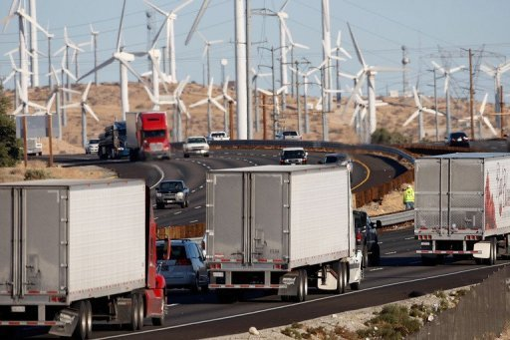In Minilab 9 we explored data on the current production of electric energy from renewable sources in California in the past month (March 2106). We have also pointed out that variability of these sources poses one of the main problems for maintaining the stable operation of the electric grid. Currently, the grid relies heavily on burning fossil fuels, as well as hydro- and nuclear energy to match variable demand of consumers.

There is little doubt that production of solar energy varies from daytime to nighttime. However, it is less obvious with respect to the wind.

In this homework, you have to answer a simple question: is the difference in wind energy produced during the day and at nighttime in March 2016 significant, or is it purely due to chance? (**10 points** total)

You may find the DS8 <https://data-8.appspot.com/sp16/unit?unit=6&lesson=31> and <https://data-8.appspot.com/sp16/unit?unit=6&lesson=33>

lecture, *code examples* and reading material useful in supporting your answer.

Here is a possible approach to the problem:

1. Focus on two particular time intervals (for example, noon vs midnight hour).
2. Explore the distribution of wind energy produced at selected time intervals.
3. Define a *statistic* that characterizes the amount of energy produced.
4. Explore the sampling distribution (the probability distribution of the statistic), approximated by its empirical distribution, for both time intervals.
5. Compare the two, draw your conclusion, and provide necessary illustrations explaining why you made it.

Your submission must contain both a PDF file with your report and the ipynb with the code you used to explore the data and support your conclusions.